STRICTLY CONFIDENTIAL
Application Form for the Vulnerable 16-19 Bursary Fund for 2020-21

To be eligible to receive a bursary you need to be under 19 years of age on 31st August 2020 in the academic year in which you start your study.

You may be eligible for a bursary of up to £1,200 and be either a Young Person in Care, Care Leaver, Young Person receiving Income Support or Universal Credit or receiving Disability Living Allowance or Personal Independence Payments in their own right as well as Employment and Support Allowance or Universal Credit in their own right.

If there is any information on this form which you are not sure about or if you would like some help completing the form, then please contact Safeguarding Officers, Amersham, Alex Weatherburn 01494 585262, Aylesbury, Alex Pazik: 01296 588514 / Angela Knowlton: 01296 780537, High Wycombe, Melissa Miller - 01494 585387 or email:
studentservices@buckscollegegroup.ac.uk. A Safeguarding Officer will discuss the bursary with the appropriate Authority or Carer to make sure students receive their correct entitlement.

Section 1: Your Personal Details
Surname |  |  |  | First Name |  |  | Student ID Number
Address

Post code:
Home number: | Mobile number: |  |  |  | Age on 31st August 2020
Date of Birth: | Email:
What is your status in the UK? (Please circle)
British/ EU citizen Refugee Asylum Seeker Other

Have you lived in the UK/EEA for the past 3 years?
Yes (Go to Section 2) No (Please specify below)

If no, where did you live?

Section 2: External Support Providers (e.g. Social Care, Foster Care)

External Support Provider name: |  | Address  Post code:
Telephone:

Please provide a relative/next of kin/appropriate adult that we may contact (In the event of an emergency).

Contact Name | Telephone Number  Email | Relationship to you

Section 3: Your Course Details

2020-2021 Course Name:  Campus Name: | Level | Full Time/Part Time
Have you studied at Bucks College Group before? Yes No

If yes, what was the Course name, level and year?

Have you received financial assistance from Bucks College Group before? Yes No

Section 4: Income Details and Evidence Needed.

(NOTE: Benefits must be paid to you directly NOT to your parents/carers)

Please tick every box and provide evidence
Evidence Required
Are you in care or a care leaver? | Yes | The Local Authority will provide you with a letter confirming this.
 | No
Are you receiving Income Support or Universal Credit? | Yes | Please provide a photocopy of an up to date letter from the department of Work and Pensions (DWP) setting out the benefit you are entitled to.
 | No
Are you in receipt of Personal Independent Payment (PIP), or  Disability Living  Allowance (DLA) AND  Employment Support Allowance (ESA)? | Yes | Please provide a photocopy of an up to date letter from the department of Work and Pensions (DWP) setting out the benefit you are entitled to.
 | No
Will you receive any other financial assistance?  (Weekly allowance from  County, Bus pass, money for kit etc) | Yes | Please provide information on what assistance you will be receiving and from where.
 | No

Please use this space to identify any additional financial need that you feel would assist you in completing your studies. Please do not include travel or additional course costs.

Section 6: Your Bank Details
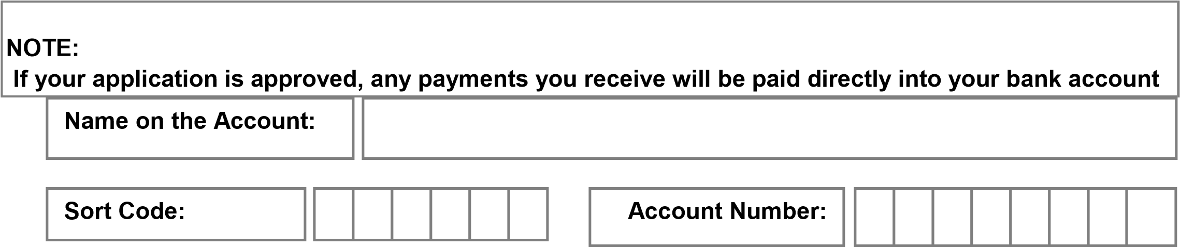

Section 7: Declaration

Please read this information carefully and sign if you understand and accept the following conditions:

Bucks College Group may approve this application before you start your course but funding will only be allocated once your enrolment is completed.

The funding can be withdrawn if your attendance falls below 90% (not including authorised absences) or your behaviour is unacceptable.

If for any reason you withdraw from your course you will be liable for all costs incurred.

If you do not reach the required 90% attendance the previous week then your payment is likely to be put on hold for a week

Any award made will be for the 2020-2021 academic year only. You will be informed about the outcome of your application by email within four weeks of receipt of your application.

Data Protection:

The information on this form is required by Bucks College Group to assess your eligibility for financial support. It may be passed to other agencies that require it for the sole purpose of accessing or recording support.

By signing you give your consent to Bucks College Group for recording and processing this information.

You will also be agreeing to Student Services Staff (including the Safeguarding Officer) at Bucks College Group talking to your parents or guardians about any finances linked to the College Support Scheme. This will include discussing your attendance throughout your course if it becomes an ongoing issue.

I have read and understand the conditions and I confirm that the information I have provided is true and complete.

Signed: | Date:

Please return via post or email on the details below.

Amersham Campus -STRICTLY CONFIDENTIAL, Student Services, FREEPOST AL830 Bucks College Group, Amersham Campus, Stanley Hill, Amersham, Bucks. HP7 9HN

Aylesbury Campus - STRICTLY CONFIDENTIAL, Student Services, FREEPOST AL830 Bucks College Group, Aylesbury College, Oxford Road, Aylesbury, Bucks. HP21 8PD

Wycombe Campus -STRICTLY CONFIDENTIAL, Student Services, FREEPOST AL830
Bucks College Group, Wycombe Campus, Spring Lane, Flackwell Heath, Bucks, HP10 9HE

Email: studentservices@buckscollegegroup.ac.uk

For Office use only:
Does this student get a bus or train pass from the council etc? Has this student had kit, uniform, books or other course related costs paid by another organisation?
Yes No
Calculations Notes:
Lunch

Travel

Course Contribution Costs

Other Expenses

Total

Student Services Officer:………………………………………………….Date:
Head of Student Services:………………………………………………..Date:
Executive Director:………………………………………………………...Date:
(Student Services) + £1000

