

***BUCKINGHAMSHIRE COLLEGE GROUP***

***UAL LEVEL 2 - PRODUCTION AND PERFORMING ARTS***

Dear Student,

I look forward to seeing you in September at Amersham Campus to join us in studying Level 2 Production and Performing Arts. I hope you are all well during and keeping safe.

The current Level 2 students have finished their final major project where we did our own version of The Wizard of Oz.

This pack is just to let you know what you can expect when joining us in September. I look forward to seeing you at the start of the year.

If you have any questions, please contact me.

**Zara Milton**

**Level 2 - Production and Performing Arts Course Leader**

**[zmilton@buckscollegegroup.ac.uk](mailto:zmilton@buckscollegegroup.ac.uk)**

**Course Overview**

The UAL Level 2 Production and Performing Arts is a course that lasts one year. I have designed the course around students finding confidence and preparing for their journey to Level 3. The course is set up with 9 Units. It is a very practical based course. With theory work to support the practical side. The units are based around different projects ranging from Storytelling, Christmas show with Level 3 students, Getting ready for auditions and an end of year performance. This course is based on building students confidence , getting students ready for Level 3 courses of their choice and building their knowledge in the performing arts industry. There is a chance to work in the ‘Theatre on the hill’ with Level 3 students during the Christmas show or have your own Christmas show , and a chance to work in one of our smaller theaters for our end of year show. There are a lot of exciting projects to look forward to on this course and they all help build your confidence ready for your next step.

Classes are based around students building confidence, which is done throughout the lesson. Starting with warm up exercises or games which link to what we will be doing in each lesson and the learning outcome. In classes students will be taught skills that include Acting, Dance and Singing to prepare them for their chosen progression routes. In their last assignment students will also take on a role of the production and technical side of theatre, for example, Costume, Set Designer and Props etc. Students will learn a variety of skills to do with the Performing Arts Industry throughout their time on the Level 2 course.

**Course Teachers and subjects**

**Zara Milton -** Acting, Singing and Theory Skills.

**Helen Charalambous -** Fitness, Musical Theatre Dance Skills, and Contemporary Dance with Physical Theatre Elements.

**Assessments**

On this course you will be assessed over a few projects throughout the year. The first few projects are leading up to the final project your end of year show. The projects all help build your confidence and prepare you for your last performance and your chosen progression route. A few of them are Storytelling, Christmas show with level 3s, Getting ready for an audition and then leading to your end of year show. The details of these assignment briefs will be given to you throughout the course and you will be guided through each assignment by your teachers. Your final assignment is the End of year show and this will be assessed with a pass, merit or distinction. An on going assessment throughout the course will be keeping a logbook of what you have learnt each lesson and how what you have learnt helps you in future performances.

**Transition task**

One of the first projects we will be working on will be Storytelling.

I would like you over the summer, to be familiar with any three different fairy-tales or stories that are appropriate for children between the age 10-12.

Keeping in mind these 3 questions.

1 - Why is this appropriate for children between 10 -12?

1. What is the moral of the story?
2. What are they trying to teach children in this fairy-tale or story?

You can bring this in to college and we can discuss why you think it is appropriate.

A few examples of stories:

- High School Musical

- Snow White and the seven dwarfs

- How the elephant got his trunk

This year the Level 2 students were supposed to perform Our Day Out by Willy Russel, this is a play about a progress class from Liverpool who go on a school trip to Whales. Here is a link to watch the play on YouTube.

Have fun and enjoy it!

<https://www.youtube.com/watch?v=yC94IOtTJrc>

**Expectations of the dress code**

Comfortable clothes for moving around in, that don’t restrict movement.

Example:

- Leggings

- Comfortable T- shirts

- Tracksuit bottoms

- Trainers (for dance)

- Long hair ( bring something to tie hair back)

Examples of clothing:

[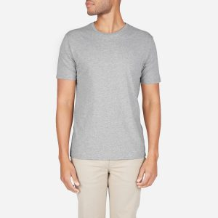](https://www.google.co.uk/url?sa=i%26url=https:/www.comfortnerd.com/10-of-the-most-comfortable-mens-t-shirt-around/%26psig=AOvVaw0q2V45koP0hEHAluGV8e_w%26ust=1588241245705000%26source=images%26cd=vfe%26ved=0CAIQjRxqFwoTCJjxuu2xjekCFQAAAAAdAAAAABAE)[](https://www.google.co.uk/url?sa=i%26url=https:/www.timberland.co.uk/shop/en/tbl-uk/outlet-collection-mens-outlet/core-1973-tracksuit-bottoms-for-men-in-grey-a1z2q052%26psig=AOvVaw30nZLiDHCYLxY-F6ID8N95%26ust=1588241178717000%26source=images%26cd=vfe%26ved=0CAIQjRxqFwoTCMipgM-xjekCFQAAAAAdAAAAABAD)[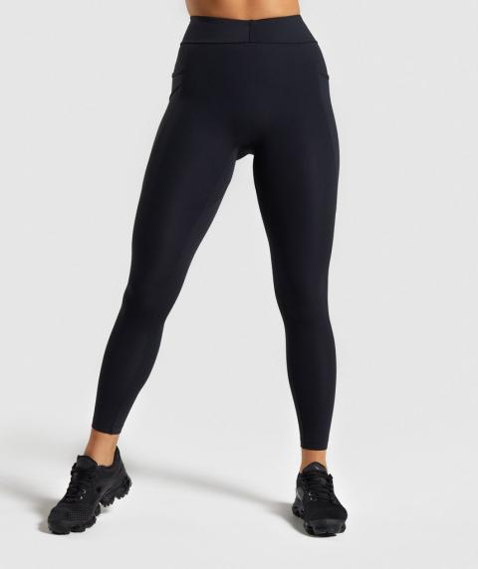](https://www.google.co.uk/url?sa=i%26url=https:/uk.gymshark.com/products/gymshark-sculpt-leggings-black%26psig=AOvVaw0Nt0-aax4p8gMkBma33pW7%26ust=1588241083673000%26source=images%26cd=vfe%26ved=0CAIQjRxqFwoTCNipqqCxjekCFQAAAAAdAAAAABAF)For Performing Arts.